**Lab Exercise 3– Terraform IAM User Setting**

**Prerequisites: Terraform Installed: Make sure you have Terraform installed on your machine. Follow the official installation guide if needed.**

AWS Credentials: Ensure you have AWS credentials (Access Key ID and Secret Access Key) configured. You can set them up using the AWS CLI or by setting environment variables.

**Exercise Steps:**

**Step 1: Create a New Directory:**

Create a new directory for your Terraform configuration:

“**Terraform-Demo”**

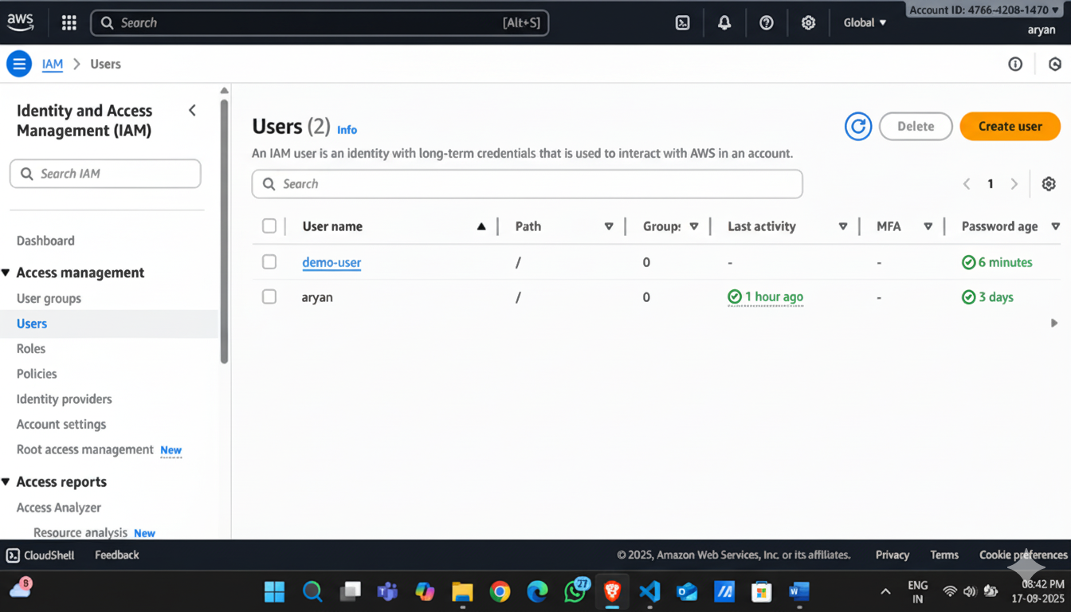

**Step 2: Create Terraform Configuration File (main.tf):**

Create a file named main.tf with the following content:

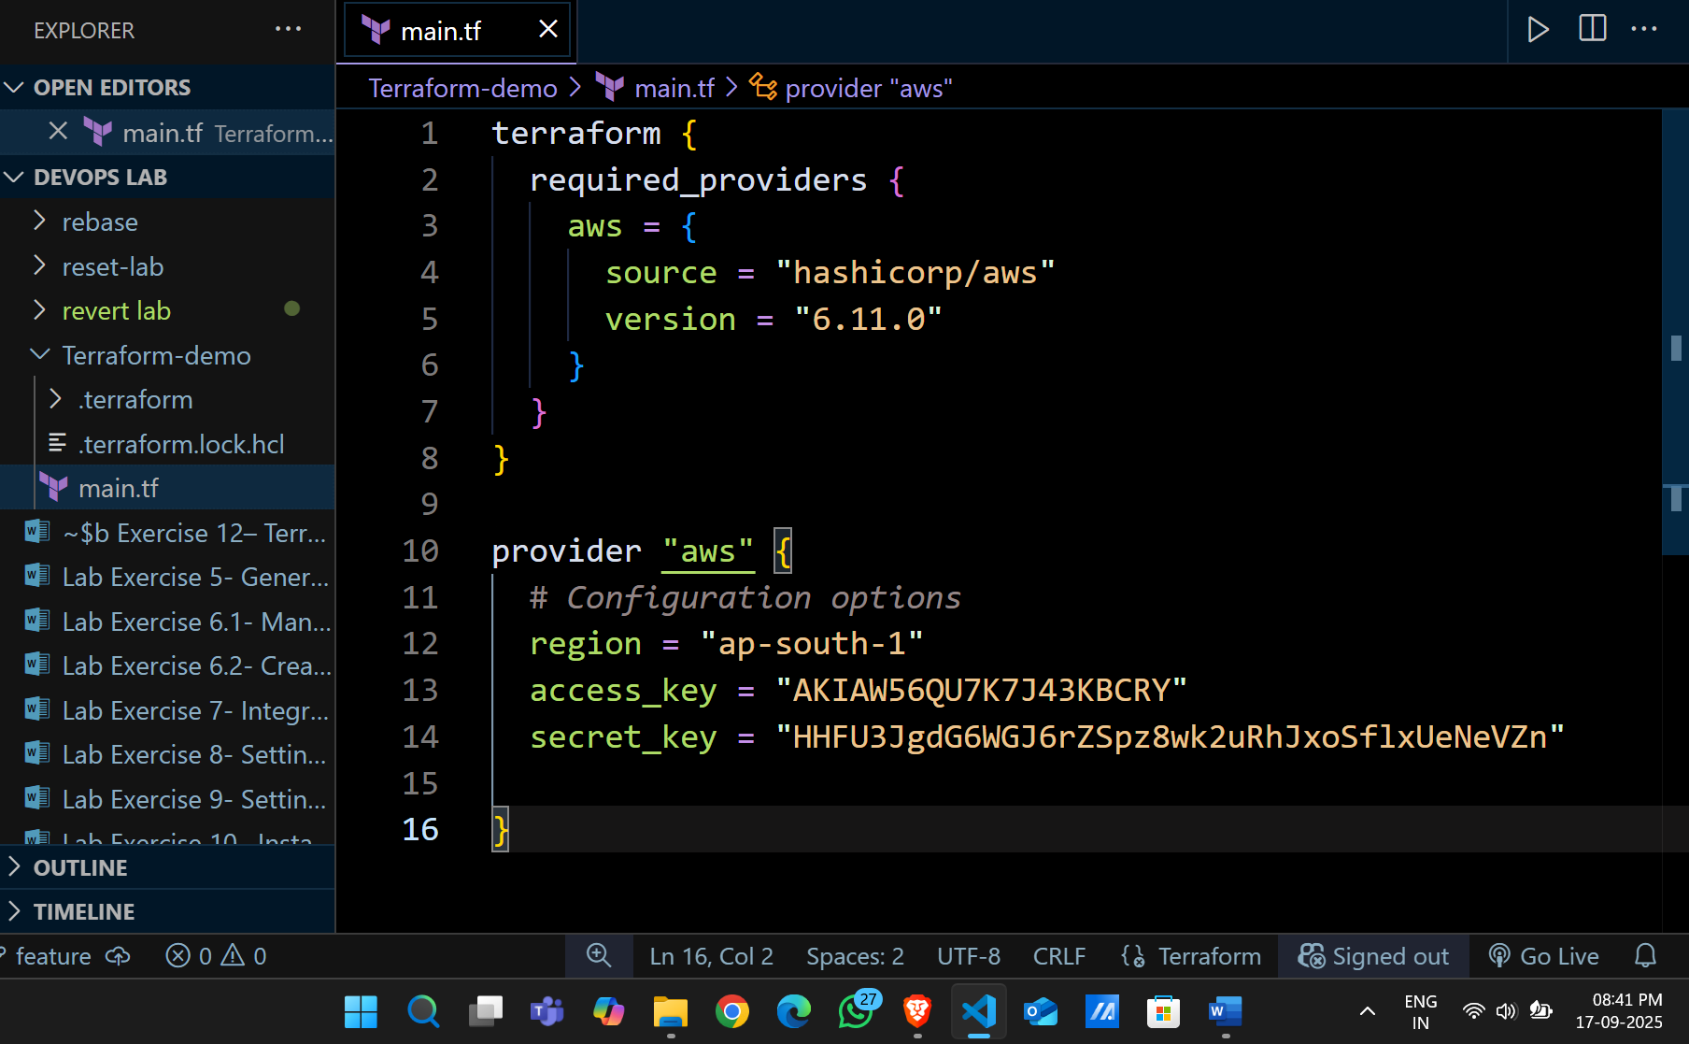

This script defines an AWS provider and provisions an EC2 instance.

**Step 3: Initialize Terraform:**

Run the following command to initialize your Terraform working directory:

